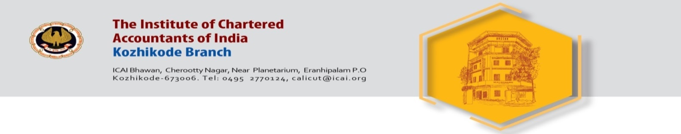

Invite you for a One Day CPE seminar on

Bank Audit

Date : Monday 21st March 2022

Venue : Hotel Paramount Tower
Town Hall Road, Kozhikode

Time : 10 AM to 5 PM

Inauguration by : Shri. PK Vijaya Kumar IRS, DGIT Retd.

Speaker 1 : CA Rajmohan R.
Trichur
Topic : Bank Audit Approach, Bank Frauds etc.

Speaker 2 : CA. Ravindran V.
Salem
Topic : NPA, LFAR and practical problems

CPE Credit 6 Hours

Registration Fee:

ARS (Calicut) Members - Free , Non ARS Members – 1,180 /-

Sd/- Sd/-
CA. Santhosh Pai G. CA. Surya Narayanan A.R.
Chairman Secretary

