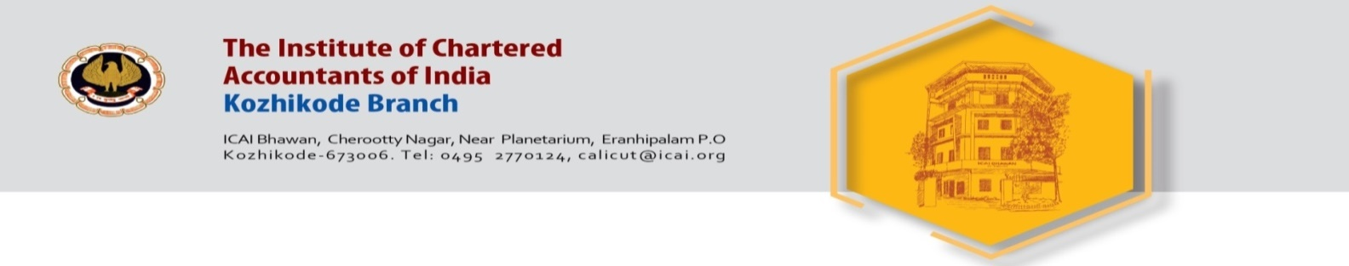

Invite you for a CPE seminar on

Tax Audit and Standards on Auditing

Date : Friday 19th August 2022

Venue : Hotel East Avenue
East Nadakkavu, Kozhikode

Time : 10 AM to 5 PM

Speakers : 1. CA. Mohan R. Lavi, Bangalore
Topic – Tax Audit

2. CA. Chinnsamy Ganesan, Chennai
Topic - Standards on Auditing

CPE Credit - 6 Hrs

Registration Fee
ARS (Calicut) Members - Free , Non ARS Members – 1180 /-

Sd/- Sd/-
CA. Santhosh Pai G. CA. Surya Narayanan A.R.
Chairman Secretary

